**Week 4 Leading Social Impacts in the Workplace**

**Tutorial A**

**Activity 1: The Gig Economy**

Read the page from the Parliament of Australia titled [Regulating the ‘gig’ economy as a form of employmentLinks to an external site.](https://www.aph.gov.au/About_Parliament/Parliamentary_departments/Parliamentary_Library/pubs/BriefingBook47p/GigEconomy" \t "_blank" \o "Link)  and watch the video [Uber deals set to give Gig workers more protectionLinks to an external site.](https://www.youtube.com/watch?v=GlGEE7cq0zI" \t "_blank" \o "Link), then answer the questions that follow.

1. What is the Gig economy?  What types of work does it involve?  
   The [Productivity Commission](http://err.parl.net/client/en_GB/search/asset/62809/0) (pp. 5, 9), [Actuaries Institute](http://err.parl.net/client/en_GB/search/asset/90439/0) (p. 9) and [Foundation for Young Australians](https://www.fya.org.au/app/uploads/2021/09/FYA-New-Work-Standard-2020.pdf) (p. 6) describe the gig economy as one where workers contract to complete a task via a digital platform that facilitates labour transactions between workers and businesses seeking to have tasks completed. The gig economy is characterized by flexible, autonomous work environments where individuals engage in short-term contracts or freelance work, often facilitated by digital platforms.

Uber and Shebah (private transport)

Uber Eats, Delivero and Menulog (meal delivery)

Freelancer, Fiverr, OneFlare, Hipages and Airtasker (task-based services).

1. What percentage of the workforce in Australia is employed in the Gig economy?  Do you think this number will increase or decrease over the next 5 years?  Why?

About 7.1% of the population in Australia have offered to work on a digital platform in the past 12 months, but only around 0.2% were doing full-time gig work and entirely reliant on that source of income. It's likely that this number will increase over the next 5 years due to technological advancements, changing economic behaviors, and the increasing demand for flexible work arrangements.

1. Why does the government in Australia want to change the laws regarding Gig workers in the country?  What are they seeking to achieve?

The government in Australia wants to change the laws regarding gig workers to provide better job security, income, and retirement savings for gig economy workers. Currently, many gig workers are classified as independent contractors, which limits their workplace entitlements and protections. By changing the laws, the government aims to ensure fairer treatment and improved conditions for gig workers.

1. How will the proposed changes to minimum pay and conditions for gig workers in Australia impact companies that rely heavily on gig economy employees?

The proposed changes to minimum pay and conditions for gig workers in Australia may impact companies that rely heavily on gig economy employees by potentially increasing their operational costs. This could lead to higher expenses for these companies, affecting their profitability and potentially requiring adjustments to their business models.

1. Do you think the price of UBER's services will likely increase or decrease if these proposed changes are implemented?  Would you be prepared to pay a higher price, knowing that gig workers are being paid a fairer wage?

The price of Uber's services would likely increase if the proposed changes are implemented, as the company may need to offset the higher costs associated with providing fairer wages and improved conditions for gig workers.

I would be prepared to pay a higher price for Uber's services to support fairer wages for gig workers.

**Activity 2 – Diversity in the Classroom**

Background: Diversity means the condition or fact of being different or varied. Diversity can refer to the differences among people, such as their race, culture, gender, sexual orientation, religion, etc.

* Diversity is often seen as a positive value that enriches society and promotes inclusion and equality.
* Inclusion means creating an environment where everyone feels welcome and valued.
* Equality means making sure everyone can access the same opportunities, regardless of their personal characteristics or circumstances.

**Activity 3 – Diversity**

Background: Diversity, inclusion and equality are three related but distinct concepts that aim to promote the fair treatment and full participation of all people. We will review the key topics from our pre-tutorial work.

Task: In your newly formed groups, you will be given time to answer one set of questions from the list below. You will then present your answer to your classmates. Remember to show your video and then lead the class in a discussion on your selected topic. Your Group number will also be your topic number. For example, Group 1 will be responsible for Topic 1.

**Topic 1: The World of Decent Work Today**

1. The video on [The World of Decent Work Today Links to an external site.](https://www.youtube.com/watch?v=JHGKyunsZBA" \t "_blank" \o "Link)argues that new technology can cause ‘disruption and turbulence’ in the workplace. Why is this so? In what ways do you think the Education sector will be disrupted by new technology?
2. How does access to employment and good working conditions contribute to positive social impacts?
3. How many people in the world are unemployed? Is this number increasing or decreasing?
4. What Sustainable Development Goal from the UN does the idea of ‘employment’ and ‘decent work’ align with? [SDG](https://sdgs.un.org/goals" \t "_blank)

**Topic 2: Will Robots Take our Jobs?**

1. Watch the following video on [Will Robots take our jobs?Links to an external site.](https://www.youtube.com/watch?v=a-7Azih0D98" \t "_blank" \o "Link) Consider how Humanoid Robots might impact the future of the workplace.  Are we likely to see a positive or negative impact on employment rates?
2. What sorts of jobs do you think Humanoid Robots might replace?  What new jobs might they create?
3. How might the United Nations (UN) make use of Humanoid robots to achieve their 17 Sustainable Development Goals? [SDG](https://sdgs.un.org/goals" \t "_blank)

**Topic 3: Diversity and Inclusion in the Workplace**

1. Watch the video on [Diversity and Inclusion in the WorkplaceLinks to an external site.](https://youtu.be/uHYuDDHvU64" \t "_blank" \o "Link) and outline What percentage of women hold boardroom roles in the 'global' companies across the world? How do you think these statistics effects a business's social impact?
2. What does 'unconscious bias' in the workplace negatively impact on?
3. What percentage of 'diverse teams' are more likely to capture 'new markets’?

**Topic 4: Fair pay and work conditions at Kellogg's**

1. In the video '*[Kellogg's Factory Working Conditions EXPOSEDLinks to an external site.](https://www.youtube.com/watch?v=70tO0EGEeVs&ab_channel=MorePerfectUnion" \t "_blank)’,* what were the unfair working conditions Kellogg's demanded from their employees?
2. How do the actions of Kellogg's unfair work policy threaten their employees’ lives?
3. Suggest three changes Kellogg's could make to ensure they provide a positive, decent workplace.

**Topic 5: Justice and Fairness in the Workplace**

1. Read the article by [Dahanayaka P. et al. (2017) 'Justice and fairness in the workplace.pdf](https://canvas.insearch.edu.au/courses/5118/files/2335261?wrap=1" \t "_blank)[Download Dahanayaka P. et al. (2017) 'Justice and fairness in the workplace.pdf](https://canvas.insearch.edu.au/courses/5118/files/2335261/download?download_frd=1) and outline what is Organisational Justice?
2. What are the four categories of workplace justice and fairness?
3. What is the business case argument for diversity?  How is it different to the moral case argument?
4. Which approach do you think an organisation like Google would be focused on?

**Week 4 – Tutorial B**

**Leading Social Impacts in the Workplace**

**Activity 1: Understanding People with disabilities.**

Background: We will take a look at some statistics on the percentage of people living with a disability.

Task: According to the World Health Organisation (WHO) there are currently more than 1 billion people worldwide living with a disability.

Let's consider what living with a disability might look like.

1. 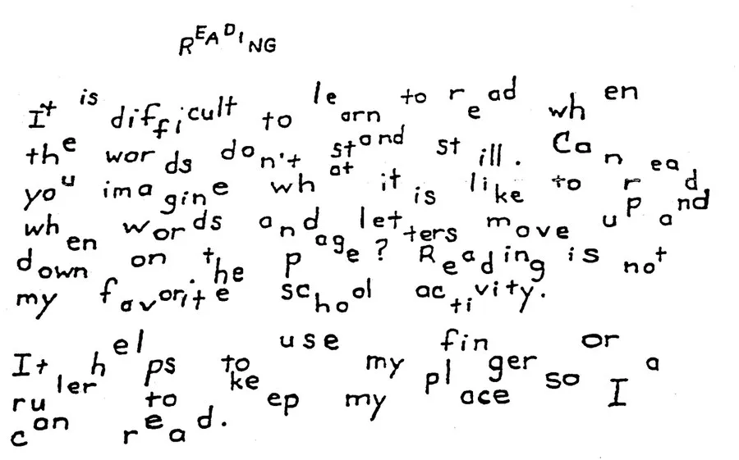When instructed by your tutor, read the passage below.  Your tutor will then select two students to read the passage to the class.

**Discussion:** How did you feel trying to read this passage?

This is an example of what reading might be like for people who have learning disabilities. People with learning disabilities might have similar feelings to the ones you experienced.

For people with learning disabilities, reading can be challenging, but that does not affect their intelligence. People with learning disabilities have average or above-average intelligence.

**People with Disabilities:**Which of these famous people do you think has a disability?

1. Emma Watson – Actress:
2. Albert Einstein - Theoretical physicist: Asperger’s & Dysgraphia
3. Bill Gates: Founder of Microsoft: Asperger’s

**Discussion**

1. Should we judge people based on their learning disabilities?

No, we shouldn't judge people based on their learning disabilities. Everyone deserves to be treated with respect and understanding, regardless of any challenges they may face. Instead of judgment, it's important to offer support and accommodations to help individuals with learning disabilities thrive.

1. What contributions can people with disabilities make to society?

People with disabilities can make significant contributions to society in various ways. They bring unique perspectives, talents, and experiences that enrich communities and workplaces. Some may excel in creative fields, entrepreneurship, advocacy, or technology, while others contribute through their resilience, empathy, and determination. By promoting inclusivity and providing opportunities for all individuals to participate fully, society can benefit from the diverse talents and strengths of people with disabilities.

1. Can you think of other famous people who have disabilities?

Stephen Hawking - Renowned theoretical physicist and cosmologist who had amyotrophic lateral sclerosis (ALS).

Frida Kahlo - Influential Mexican artist known for her vibrant and surreal paintings, who had polio as a child and later experienced a debilitating bus accident.

Stevie Wonder - Legendary musician and singer-songwriter who is blind.

You can find a list of famous people who have disabilities in the link below:

<https://blog.ongig.com/diversity-and-inclusion/famous-people-with-disabilities/>

**Activity 2: Overcoming barriers for those with disabilities**

Your tutor will show you a video on Access and Inclusion is Good for Business. Use this together with the Darcy Simons video from the “Between Tutorials” to answer the questions below.

1. What are some common barriers to employment for people with disability?

Some common barriers to employment for people with disabilities include:

1. Discrimination: Prejudice and stereotypes about disabilities can lead to discrimination in hiring, promotion, and workplace practices.

2. Accessibility: Physical barriers in the workplace, such as lack of ramps or elevators, can make it difficult for people with mobility impairments to access job opportunities.

3. Limited access to education and training: People with disabilities may face challenges in accessing quality education and vocational training programs that prepare them for employment.

4. Social stigma: Negative attitudes and misconceptions about disabilities can create social barriers and affect how individuals with disabilities are perceived in the workplace.

1. Why should employers seek to hire people with disability? (consider arguments for the ‘business case’ and ‘moral case’ for diversity)

The Business case: It makes good business sense.

Diverse Perspectives: Hiring individuals with disabilities brings diverse perspectives, experiences, and problem-solving skills to the workplace, fostering innovation and creativity.

Talent Pool Expansion: Accessing the talent pool of people with disabilities expands the pool of potential employees, allowing employers to tap into a wider range of skills and abilities.

Customer Base: Employing individuals with disabilities can also attract a broader customer base, as consumers increasingly value companies that prioritize diversity and inclusion.

Productivity and Retention: Studies have shown that employees with disabilities often exhibit high levels of productivity, loyalty, and retention, leading to cost savings associated with reduced turnover and recruitment efforts.

Legal Compliance: Hiring people with disabilities ensures compliance with laws and regulations promoting equal employment opportunities, minimizing the risk of legal disputes and penalties.

The Moral case: It makes moral sense.

Equality and Fairness: Embracing diversity and inclusivity aligns with moral principles of equality and fairness, affirming the inherent worth and dignity of all individuals regardless of their abilities.

Social Responsibility: Employers have a moral obligation to contribute positively to society by providing equal opportunities for all individuals, including those with disabilities.

Community Integration: Hiring people with disabilities promotes social inclusion and integration, fostering a more compassionate and empathetic workplace culture.

Empowerment and Dignity: Offering employment opportunities to individuals with disabilities empowers them to lead fulfilling and independent lives, enhancing their sense of dignity and self-worth.

Role Modeling: By demonstrating a commitment to diversity and inclusion, employers serve as role models for other organizations and contribute to building a more equitable society.

1. What can business leaders do to provide a more accessible and inclusive workplace for those with disability?

1. Education and Training: Offer training programs for employees and managers to raise awareness about disability issues, promote understanding, and provide guidance on creating an inclusive environment.

2. Accessible Facilities: Ensure that the workplace is physically accessible by implementing accommodations such as ramps, elevators, accessible restrooms, and ergonomic workstations to accommodate employees with disabilities.

3. Technology and Tools: Invest in assistive technologies and tools to support employees with disabilities in performing their job duties effectively, such as screen readers, magnifiers, ergonomic keyboards, and speech recognition software.

4. Flexible Policies: Implement flexible work arrangements and policies, such as telecommuting, flexible scheduling, and part-time options, to accommodate the diverse needs of employees with disabilities.

4.How does increasing the participation of those with a disability in the workforce lead to positive social outcomes (social impact)?

Reduced Stigma and Discrimination: By integrating people with disabilities into the workforce, society becomes more accustomed to their presence and abilities, leading to reduced stigma and discrimination against individuals with disabilities in various aspects of life.

Promotion of Inclusivity: Increased representation of people with disabilities in the workforce promotes inclusivity and diversity, fostering a culture of acceptance and respect for individuals of all abilities.

Enhanced Economic Independence: Employment provides people with disabilities with a sense of economic independence and self-sufficiency, reducing dependence on social welfare programs and increasing their overall well-being.

Improved Financial Stability: With access to employment opportunities, people with disabilities can achieve greater financial stability, leading to improved quality of life for themselves and their families.

Contribution to Economic Growth: The participation of people with disabilities in the workforce contributes to economic growth by expanding the labor market, increasing consumer spending power, and fostering innovation through diverse perspectives and experiences.

Health and Well-being: Employment has been linked to better physical and mental health outcomes for individuals with disabilities, including increased self-esteem, social connections, and overall life satisfaction.